Chapter 6
Database Design and Implementation

6.1 Introduction to Database System
Databases are relational. PHP 5 and symfony are object-oriented. In order to access the database in an object-oriented way, an interface translating the object logic to the relational logic is required. This interface is called an object-relational mapping, or ORM.

6.1.1 The ORM Layer
An ORM is made up of objects that give access to data and keep business rules within themselves. One benefit of an object/relational abstraction layer is that it prevents you from using a syntax that is specific to a given database. It automatically translates calls to the model objects to SQL queries optimized for the current database.

This means that switching to another database system in the middle of a project is easy. Imagine that you have to write a quick prototype for an application, but the client has not decided yet which database system would best suit his needs. You can start building your application with SQLite, for instance, and switch to MySQL, PostgreSQL, or Oracle when the client is ready to decide. Just change one line in a configuration file, and it works.

An abstraction layer encapsulates the data logic. The rest of the application does not need to know about the SQL queries, and the SQL that accesses the database is easy to find. Developers who specialize in database programming also know clearly where to go.

Propel, another open source project is currently one of the best object/relational abstraction layers for PHP 5. Symfony integrates Propel seamlessly as its default ORM, so most of the data manipulation described in this book follows the Propel syntax.

6.2 Design Strategy
Relational Database approach has been selected as it has certain advantages over the conventional file approach. Separate tables for different entities contain data thus eliminating chances of data redundancy, data insecurity and duplication of data. As well it is easy to retrieve the data through these tables.

6.3 Normalization
Normalization is the process of converting complex data structures into simple and stable data structures. The main theme of this process is to divide the larger tables into smaller ones in order to remove any data dependencies and redundancies.

The database for ITP challan automation system is normalized to fourth degree. The tables for List of Values (LOVs) are separated from the challan record tables. Even the tables containing the data for challans are normalized as they have a one to many relation in them which can only be properly maintained through normalization.

6.4 Database Tables Description

The database is created in MYSQL using the PHPMyAdmin version that comes with WAMPP web server. The default collation for the tables is “utf8_general_ci” and all tables are of the type “InnoDB”. The InnoDB helps to implement proper and foreign keys and cascading techniques that are required in the ORM model. An ideal situation of 0% overhead is maintained in the tables as the update and delete cascading is properly maintained in the tables

6.4.1 Bank:
This table is used to store the different bank branches where the challans can be deposited. Each bank has a unique user that gives access to the challan receiving form upon login. The title and the branch code of the bank is taken by default upon login.

Field | Type | Null | Default
id | int(11) | No
title | varchar(255) | Yes | NULL
branch_code | varchar(50) | Yes | NULL
status | varchar(20) | Yes | NULL

Table 6.1 Bank

6.4.2 Challan:
The challan table is the normalized table for keeping the record of the one or more violations committed by the offender for a particular challan. The total challan penalty is also calculated through this table on runtime, depending upon the browsed ticket.

Field | Type | Null | Default
id | int(11) | No
ticket_id | int(11) | Yes | NULL
offence_id | int(11) | Yes | NULL
offence_penalty | float(13,2) | Yes | NULL

Table 6.2 Challan

6.4.3 Department:
This is LoV table required to identify the department of the employees registered in the system. It is presented so as to give the flexibility to the system administrator to create multiple departments and customize the system according to the organizational structure.

Field | Type | Null | Default
id | int(11) | No
title | varchar(100) | Yes | NULL
status | varchar(50) | Yes | NULL
created_at | date | Yes | NULL
updated_at | date | Yes | NULL

Table 6.3 Department

6.4.4 Designation:
This is LoV table required to identify the designations of the employees registered in the system. System administrator can create multiple designations corresponding to the each department.

Field | Type | Null | Default
id | int(11) | No
department_id | int(11) | Yes | NULL
title | varchar(100) | No
status | varchar(50) | Yes | NULL
created_at | date | Yes | NULL
updated_at | date | Yes | NULL

Table 6.4 Designation

6.4.5 Document:
This table keeps the LoV for the confiscated document(s) at the time of challan. The currently used documents are added by default but they can be altered (both edited and deleted) any time by the system administrator.

Field | Type | Null | Default
id | int(11) | No
title | varchar(255) | Yes | NULL
status | varchar(20) | Yes | NULL
created_at | date | Yes | NULL
updated_at | date | Yes | NULL

Table 6.5 City Location

6.4.6 Employee:
This table stores the bio-data, employee’s information and the system related information for the Human Resource.

Field | Type | Null | Default
id | int(11) | No
department_id | int(11) | Yes | NULL
designation_id | int(11) | Yes | NULL
role_id | int(11) | Yes | NULL
belt_no | varchar(50) | Yes | NULL
name | varchar(100) | Yes | NULL
father_name | varchar(100) | Yes | NULL
cnic | varchar(50) | Yes | NULL
dob | date | Yes | NULL
gender | varchar(10) | Yes | NULL
mail_address | varchar(255) | Yes | NULL
permanent_address | varchar(255) | Yes | NULL
contact_res | varchar(50) | Yes | NULL
contact_cell | varchar(50) | Yes | NULL
contact_off | varchar(50) | Yes | NULL
emergency_contact | varchar(50) | Yes | NULL
employment_date | date | Yes | NULL
experience_year | int(11) | Yes | NULL
local_resident | varchar(3) | Yes | NULL
disease | varchar(255) | Yes | NULL
blood_group | varchar(5) | Yes | NULL
qualification | varchar(1000) | Yes | NULL
status | varchar(10) | Yes | NULL
created_at | date | Yes | NULL
updated_at | date | Yes | NULL

Table 6.6 Employee

6.4.7 Offence:
This table stores the different kinds of offence/violations and their penalties that are defined by ITP.

Field | Type | Null | Default
id | int(11) | No
serial | varchar(10) | Yes | NULL
title | varchar(1024) | Yes | NULL
description | varchar(255) | Yes | NULL
penalty | float(13,2) | Yes | NULL
status | varchar(10) | Yes | NULL
created_at | date | Yes | NULL
updated_at | date | Yes | NULL

Table 6.7 Offence

6.4.8 Place:
Place table stores the all possible places where the traffic wardens may challan the offenders. Places are stored with reference to the Zones they lay in.

Field | Type | Null | Default
id | int(11) | No
zone_id | int(11) | Yes | NULL
title | varchar(100) | Yes | NULL
description | varchar(255) | Yes | NULL
status | varchar(20) | Yes | NULL

Table 6.8 Place

6.4.9 Role:
This table defines the roles of the system users.

Field | Type | Null | Default
id | int(11) | No
title | varchar(50) | Yes | NULL
status | varchar(10) | Yes | NULL
created_at | date | Yes | NULL
updated_at | date | Yes | NULL

Table 6.9 Role

6.4.10 Ticket:
This is the main table for the record keeping of challan information including the offender’s information, vehicle type and registration etc.

Field | Type | Null | Default
id | int(11) | No
employee_id | int(11) | Yes | NULL
zone_id | int(11) | Yes | NULL
place_id | int(11) | Yes | NULL
document_id | int(11) | Yes | NULL
vehicle_type_id | int(11) | Yes | NULL
bank_id | int(11) | Yes | NULL
book_no | varchar(50) | Yes | NULL
ticket_no | varchar(50) | Yes | NULL
offender_name | varchar(100) | Yes | NULL
offender_father | varchar(100) | Yes | NULL
cnic | varchar(50) | Yes | NULL
gender | varchar(10) | Yes | NULL
reg_no | varchar(20) | Yes | NULL
reg_to | varchar(100) | Yes | NULL
offence_date | date | Yes | NULL
offence_time | time | Yes | NULL
date_paid | date | Yes | NULL
status | varchar(10) | Yes | NULL
created_at | date | Yes | NULL
updated_at | date | Yes | NULL

Table 6.10 Ticket

6.4.11 User:
All authentic users are registered in this table.

Field | Type | Null | Default
id | int(11) | No
role_id | int(11) | Yes | NULL
employee_id | int(11) | Yes | NULL
bank_id | int(11) | Yes | NULL
user | varchar(50) | Yes | NULL
password | varchar(50) | Yes | NULL
status | varchar(20) | Yes | NULL
created_at | date | Yes | NULL
updated_at | date | Yes | NULL

Table 6.11 User

6.4.12 Vehicle Type:
An LoV table for the types of vehicles.

Field | Type | Null | Default
id | int(11) | No
title | varchar(255) | Yes | NULL
status | varchar(20) | Yes | NULL
created_at | date | Yes | NULL
updated_at | date | Yes | NULL

Table 6.12 Vehicle Type

6.4.13 Zone:
An LoV table for the zones that prevail in the Islamabad capital territory.

Field | Type | Null | Default
id | int(11) | No
title | varchar(255) | Yes | NULL
status | varchar(20) | Yes | NULL
created_at | date | Yes | NULL
updated_at | date | Yes | NULL

Table 6.13 Zone

6.5 System Diagram with Primary and Foreign Keys

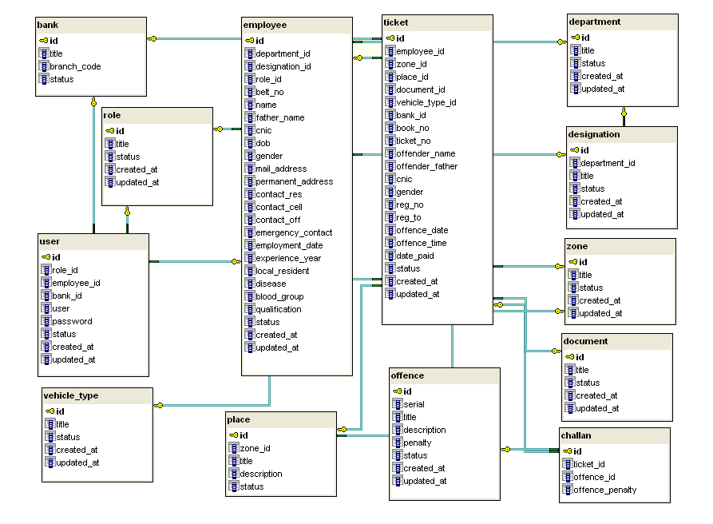Figure 6.1: Systems Tables with primary and foreign keys.

